**Report: act_report**

Create a 250-word-minimum written report called \"act_report.pdf\" or \"act_report.html\" that communicates the insights and displays the visualization(s) produced from your wrangled data. This is to be framed as an external document, like a blog post or magazine article, for example.

**Introduction**

This report looks to build on the wrangle_report and will present the insights and visualizations from the Project. The Insights presented stem from a few questions that I wanted to be answered. They Include;

**Most Common Dog**

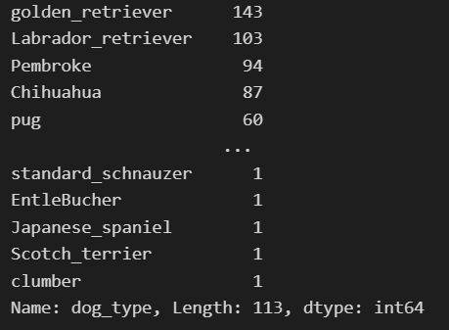

From the Code snippet, We can see the Golden retriever is the most common dog.

**Dogs with most and least ratings**

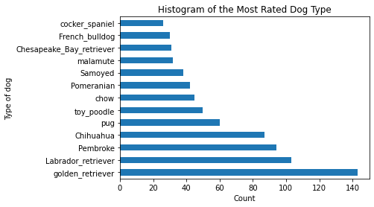

The Cocker Spaniel had the lowest ratings received whilst unsurprisingly the Golden Retriever had the highest ratings received

**Most and Least Common Dog Names.**

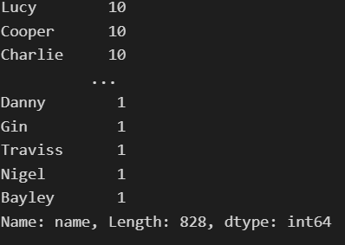

We can see that Lucy, Cooper and Charlie are the most common dog names while Danny, Gin, Traviss, Nigel and Bayley are among the least common names.